**OPERATOR AND CONTROL STRUCTURES**

1. Write a program to read in two integers and perform the following operations on them: addition, subtraction, multiplication, division, and modulo.

#include <iostream>

int main() {

int num1, num2;

std::cout << "Enter the first integer: ";

std::cin >> num1;

std::cout << "Enter the second integer: ";

std::cin >> num2;

int sum = num1 + num2;

int difference = num1 - num2;

int product = num1 * num2;

double quotient = static_cast<double>(num1) / num2;

int modulo = num1 % num2;

std::cout << "Addition: " << sum << std::endl;

std::cout << "Subtraction: " << difference << std::endl;

std::cout << "Multiplication: " << product << std::endl;

std::cout << "Division: " << quotient << std::endl;

std::cout << "Modulo: " << modulo << std::endl;

return 0;

}

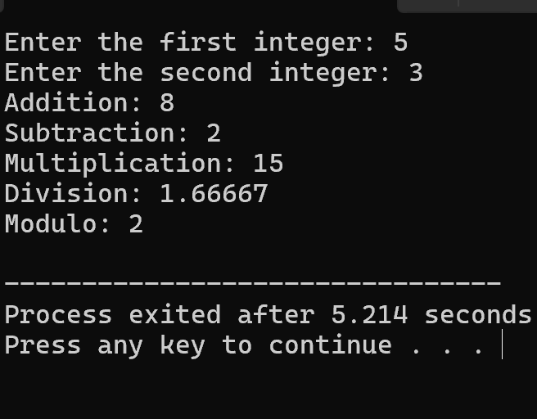

1. Program to determine the integer is odd or even

#include <iostream>

using namespace std;

int main() {

int num;

cout << "Enter an integer: ";

cin >> num;

if (num % 2 == 0) {

cout << num << " is even" <<endl;

} else {

cout << num << " is odd" << endl;

}

return 0;

}

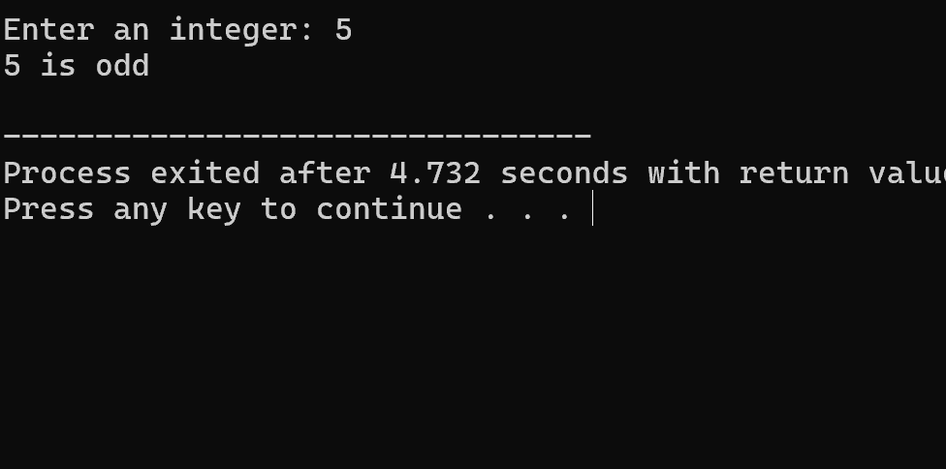

1. Program to compute the average of three integers

#include<iostream>

using namespace std;

int main(){

int a=10;

int b=20;

int c=30;

int average;

average=(a+b+c)/3;

cout<<a<<","<<b<<"and"<<c<<"is"<<average<<endl;

}

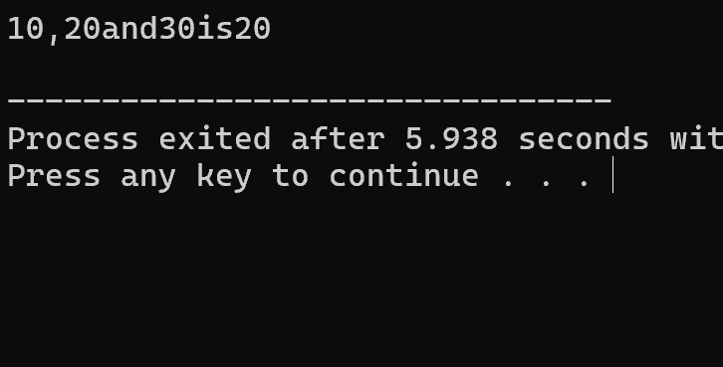

1. Program to check two numbers are equal or not

#include <iostream>

using namespace std;

int main() {

int num1, num2;

cout << "Enter the first integer: ";

cin >> num1;

cout << "Enter the second integer: ";

cin >> num2;

if (num1 == num2) {

cout << "The numbers are equal." <<endl;

} else {

cout << "The numbers are not equal." <<endl;

}

return 0;

}

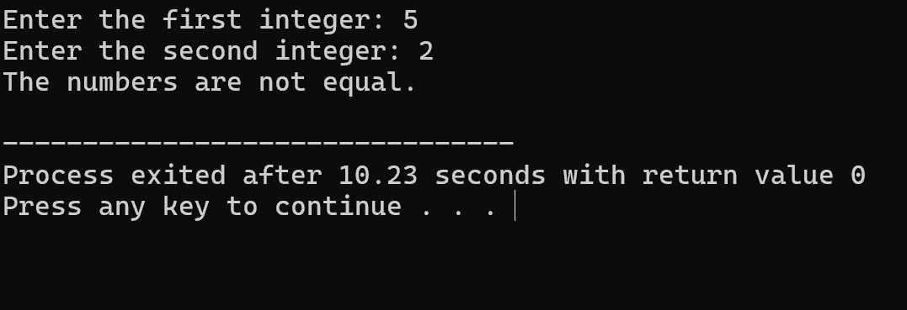

1. Write a program to read in two Floating numbers and perform the following operations on them: addition, subtraction, multiplication, division, and modulo.

#include <iostream>

#include <cmath>

using namespace std;

int main() {

double num1, num2;

cout << "Enter the first floating-point number: ";

cin >> num1;

cout << "Enter the second floating-point number: ";

cin >> num2;

double addition = num1 + num2;

double subtraction = num1 - num2;

double multiplication = num1 * num2;

double division = num1 / num2;

double modulo = fmod(num1, num2);

cout << "Addition: " << addition <<endl;

cout << "Subtraction: " << subtraction << endl;

cout << "Multiplication: " << multiplication << endl;

if (num2 != 0) {

cout << "Division: " << division << endl;

cout << "Modulo: " << modulo << endl;

} else {

cout << "Division and Modulo by zero are undefined." << endl;

}

return 0;

}

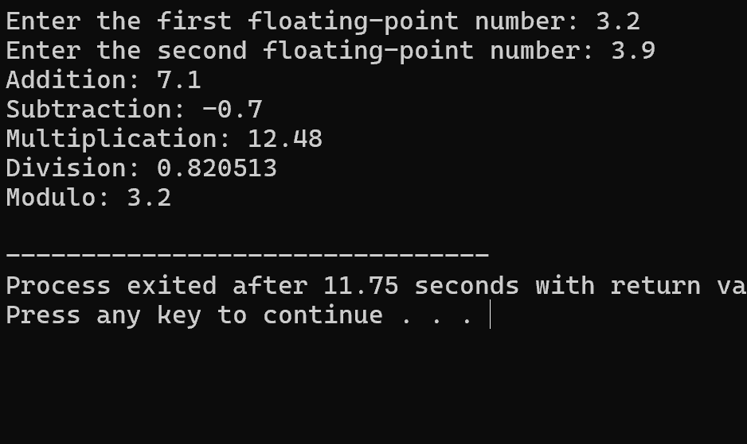

1. Program to check the character is a vowel or consonant

#include <iostream>

using namespace std;

int main() {

char ch;

cout << "Enter a character: ";

cin >> ch;

ch = tolower(ch);

if (ch == 'a' || ch == 'e' || ch == 'i' || ch == 'o' || ch == 'u') {

cout << ch << " is a vowel." << endl;

} else if ((ch >= 'a' && ch <= 'z')) {

cout << ch << " is a consonant." << endl;

} else {

cout << ch << " is not an alphabet character." << endl;

}

return 0;

}

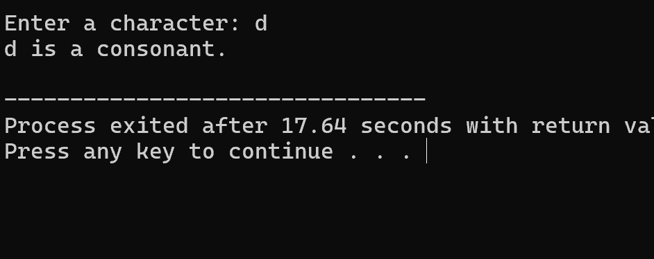

1. Program to check the number is positive, negative or zero

#include <iostream>

using namespace std;

int main() {

int number;

cout << "Enter a number: ";

cin >> number;

if (number > 0) {

cout << "The number is positive." << endl;

} else if (number < 0) {

cout << "The number is negative." << endl;

} else {

cout << "The number is zero." << endl;

}

return 0;

}

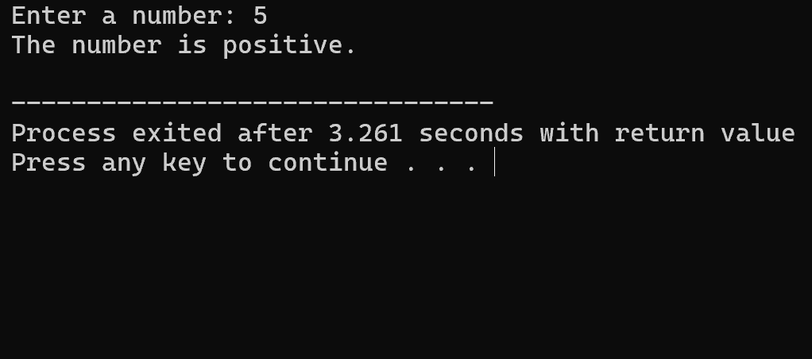

1. Program to determine which number is greater among two integers

#include<iostream>

using namespace std;

int main(){

int a,b;

cout<<"enter 2 numbers:";

cin>>a>>b;

if(a>b){

cout<<"a is greater:";

}else{

cout<<"b is greater:";

}

return 0;

}

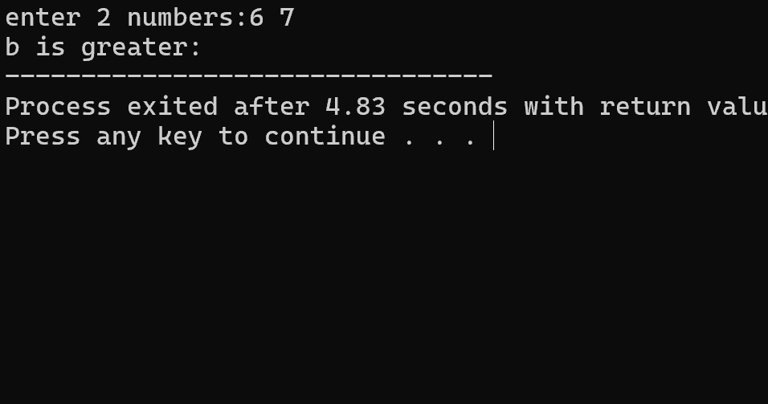

1. Program to read a floating-number and round it to the nearest integer using the floor an ceil functions.

#include<iostream>

#include<cmath>

using namespace std;

int main(){

int a;

float b;

cout<<"enter a float number:";

cin>>b;

int c= floor(b);

int d= ceil(b);

if((b-c)<(d-b)){

a=c;

}else{

a=d;

}

cout<<"original number:"<<b<<endl;

cout<<"rounded number:"<<a<<endl;

return 0;

}

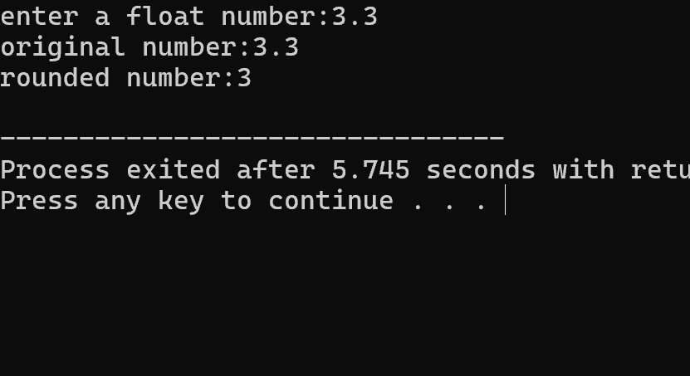

1. Program to swap two numbers using bitwise XOR operator

#include <iostream>

using namespace std;

int main() {

int num1, num2;

cout << "Enter the first integer: ";

cin >> num1;

cout << "Enter the second integer: ";

cin >> num2;

cout << "Before swapping: num1 = " << num1 << ", num2 = " << num2 << endl;

num1 = num1 + num2;

num2 = num1 - num2;

num1 = num1 - num2;

cout << "After swapping: num1 = " << num1 << ", num2 = " << num2 << endl;

return 0;

}

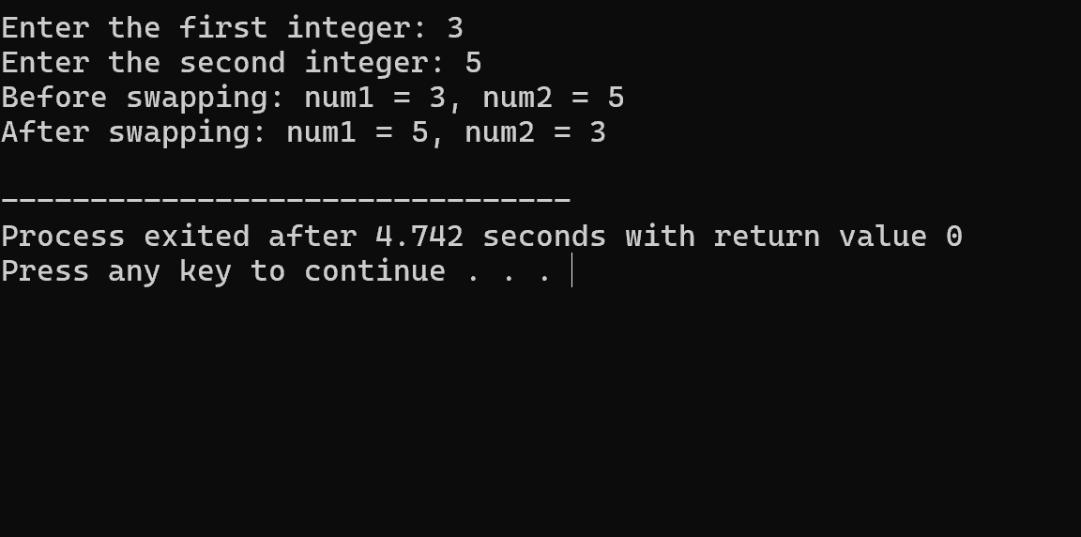

1. Largest among three numbers using ternary conditional operator

#include<iostream>

using namespace std;

int main(){

int a,b,c;

cout<<"enter three numbers:";

cin>>a>>b>>c;

int large=(a>b)?((a>c)?a:c):((b>c)?b:c);

cout<<"largest number="<<large<<endl;

return 0;

}

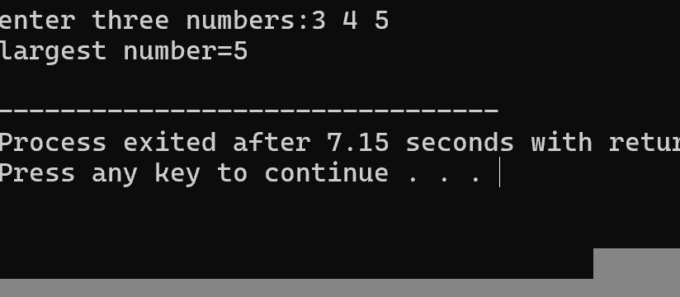

1. Program to check two numbers are equal or not using ternary conditional operator

#include<iostream>

using namespace std;

int main(){

int a,b;

cout<<"enter 2 numbers:";

cin>>a>>b;

string eq =(a==b) ? "equal":"not equal";

cout<<eq;

return 0;

}

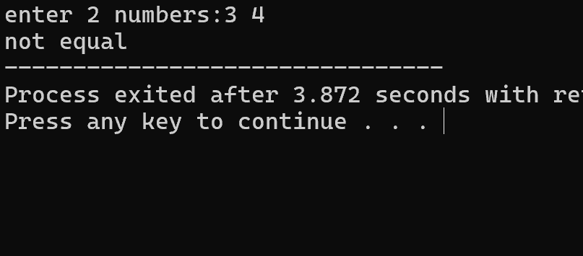

1. Program to check the integer is divisible by 3 or not using ternary conditional operator

#include<iostream>

using namespace std;

int main(){

int a;

cout<<"enter a numbe:";

cin>>a;

string div=(a%3==0)?"divisible":"not divisible";

cout<<"the given number is "<<div<<endl;

return 0;

}

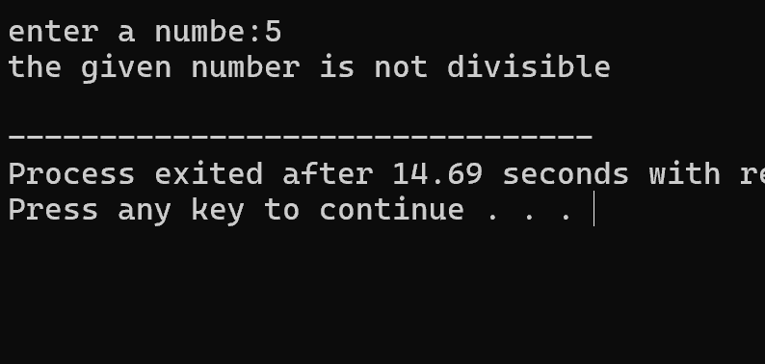

1. Program to print numbers from 1 to 10 using for loop

#include<iostream>

using namespace std;

int main(){

int a=10;

for(int i=1;i<=10;i++){

cout<<i<<endl;

}

return 0;

}

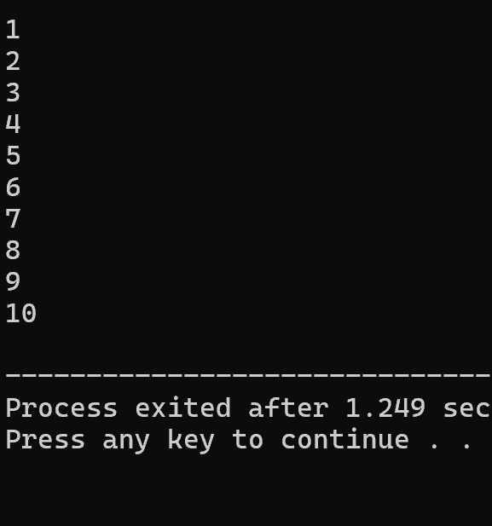

1. Factorial of a number using for loop

#include<iostream>

using namespace std;

int main(){

int a,fact=1;

cout<<"enter a number:";

cin>>a;

for(int i=1;i<=a;i++){

fact*=i;

}

cout<<"factorial of "<<a<<" is "<<fact;

return 0;

}

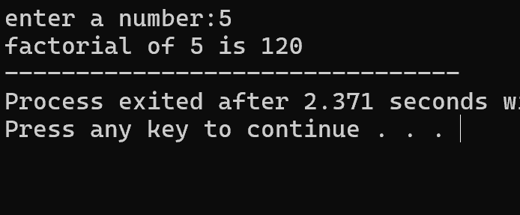

1. Print multiplication table using for loop

#include<iostream>

using namespace std;

int main(){

int a;

cout<<"enter a number:";

cin>>a;

cout<<"multiplication table for "<<a<<endl;

for(int i=1;i<=10;i++){

cout<<a<<" * "<<i<<" = "<<a*i<<endl;

}

return 0;

}

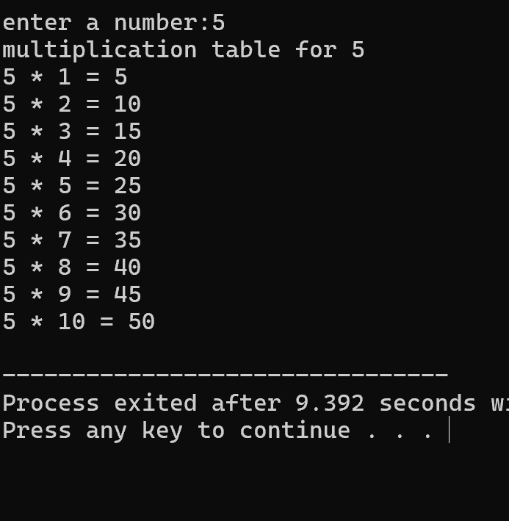

1. Fibonacci series using for loop

#include<iostream>

using namespace std;

int main(){

int a,f=0,s=1;

cout<<"enter the number:";

cin>>a;

for(int i=0;i<=a;i++){

if(i==0){

cout<<f;

}else if(i==1){

cout<<s;

}else{

int temp=f+s;

f=s;

s=temp;

cout<<temp;

}

}

return 0;

}

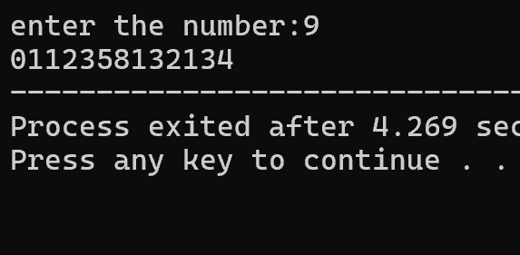

1. Prime number using for loop

#include<iostream>

using namespace std;

int main(){

int a,c=0;

cout<<"enter a number:";

cin>>a;

for(int i=1;i<=a;i++){

if(a%i==0){

c++;

}

}

if(c==2){

cout<<"prime";

}else{

cout<<"not prime";

}

return 0;

}

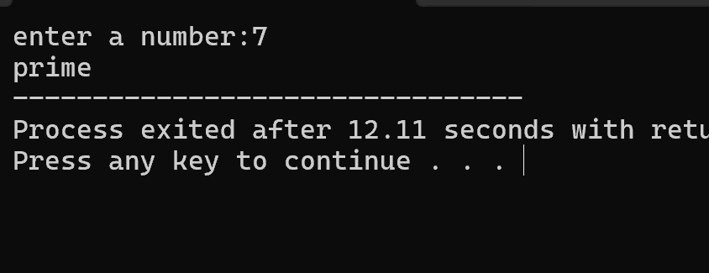

1. Check the string is palindrome or not using while loop

#include<iostream>

using namespace std;

int main(){

int a,sum=0;

cout<<"enter a number:";

cin>>a;

int temp=a;

while(temp!=0){

int b=temp%10;

sum=(sum*10)+b;

temp/=10;

}

if(a==sum){

cout<<"palindrome";

}else{

cout<<"not palindrome";

}

return 0;

}

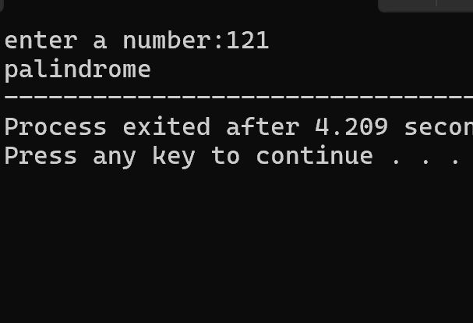

1. Sum of all digits using while loop (n=123 output:1+2+3=6)

#include<iostream>

using namespace std;

int main(){

int a,sum=0,b;

cout<<"enter a number:";

cin>>a;

int temp=a;

while(temp!=0){

b=temp%10;

sum+=b;

temp/=10;

}

cout<<"sum of digits is:"<<sum;

return 0;

}

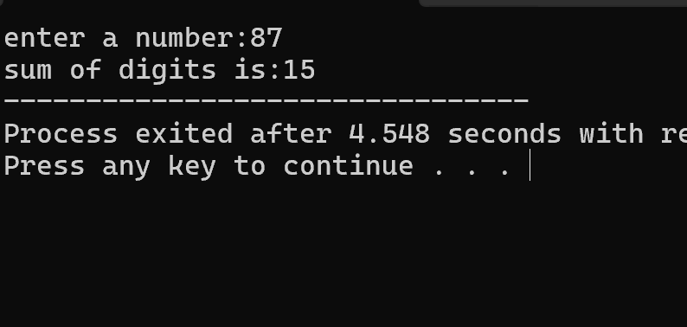

1. GCD of two numbers using do-while loop

#include<iostream>

using namespace std;

int main(){

int a,b,gcd;

cout<<"enter 2 numbers:";

cin>>a>>b;

do{

gcd=b;

b=a%b;

a=gcd;

}while(b!=0);

cout<<gcd;

return 0;

}

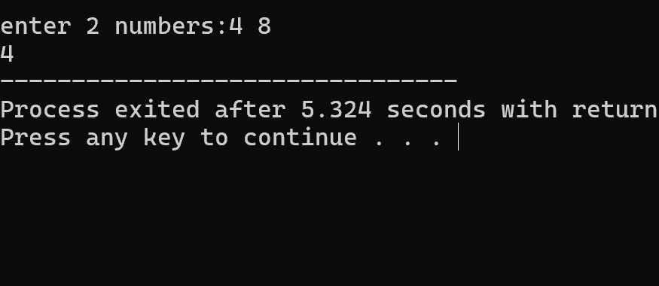

1. Check whether the number is perfect or not

#include<iostream>

using namespace std;

int main(){

int a,sum=0;

cout<<"enter a number:";

cin>>a;

for(int i=1;i<a;i++){

if(a%i==0){

sum+=i;

}

}

if(sum==a){

cout<<"perfect";

}else{

cout<<"not perfect";

}

return 0;

}

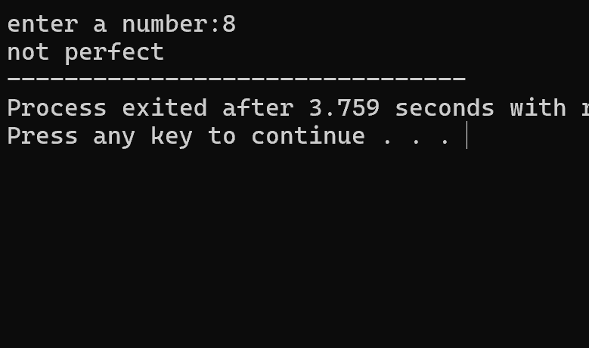

1. Armstrong number

#include<iostream>

using namespace std;

int main(){

int a,b,sum=0;

cout<<"enter a number:";

cin>>a;

int temp=a;

while(temp!=0){

b=temp%10;

sum+=b*b*b;

temp/=10;

}

if(sum==a){

cout<<"armstrong";

}else{

cout<<"not armstrong";

}

return 0;

}

